Appendix A - Mathematical Models for the AOCS and Environment

GYRO_Model
The gyro mode (coarse or fine) determines the following:
• The saturation rotation rate
• The constant and temperature dependant gyro drift rates
• The gyro noise standard deviation
• The gyro resolution
The gyro thermal control maintains the gyro temperature in a deadband of 0.1 deg C about a nominal temperature of 71.5 deg C. The control is of the form:
IF (Gyro_Temp - Nominal_Temp) > 0.5 * Deadband THEN
Switch heater off
ELSE IF (Gyro_Temp - Nominal_Temp) < -0.5 * Deadband THEN
Switch heater on
END IF
The gyro drift rate is composed of two terms:
• A constant drift rate term
• A drift rate term dependant on the difference in temperature of the gyro from the nominal temperature.
The drift rate is given by:
Drift_Rate = Constant_Drift_Rate +
ABS(Gyro_Temp - Nominal_Temp)*Temp_Dependant_Scale_Factor
The gyro output rate is given by:
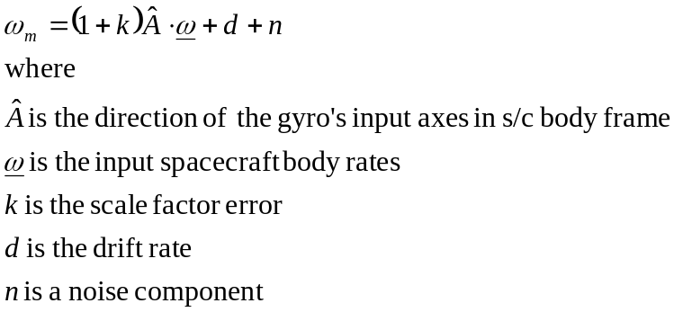
The gyro rate is tested to see if it is greater than the staturation rate. If is is then the output rate is set to the saturation rate.
The gyro angular increment is then determined from:
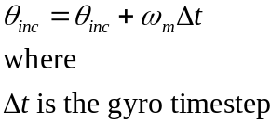
At the gyro output update time the following are performed:
If required an operator defined bias is added to the angular increment
The angular increment is discretized according to:
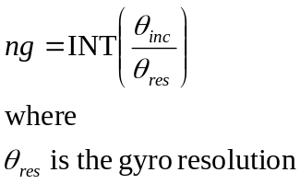
The up/down counter is then adjusted:
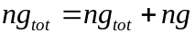
The up/down counter is a 16 bit unsigned integer with maximum value of FFFF hex and minimum value 0. The up/down counter is therefore tested for underflow/overflow:
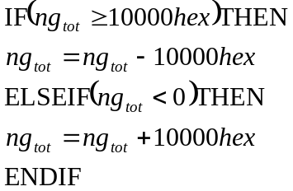
The angular increment is then reset:
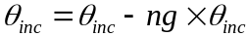

SAS_Model
The transformation of the sun vector from spacecraft body to SAS axes is given by:
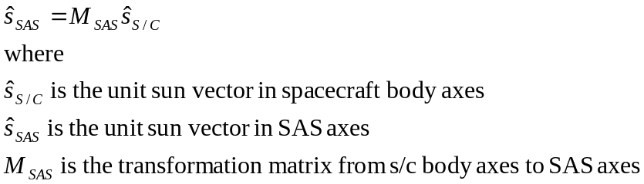
The earth vector is required for the QSS albedo model. The earth vector transformation is performed in a similar fashion.

SPI_Model
The sun angle is given by:
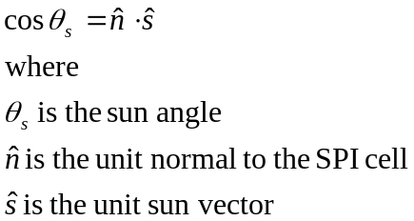
The test for the sun in the SPI field of view is given by:
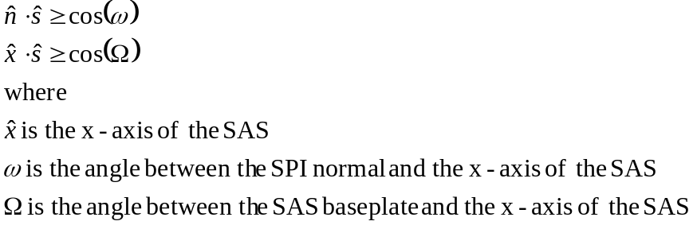
The output current is gven by:
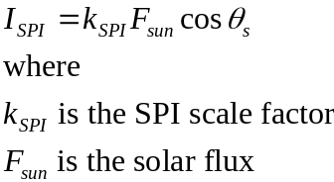

QSS_Model
The aspect angles Alpha and Beta are given by:
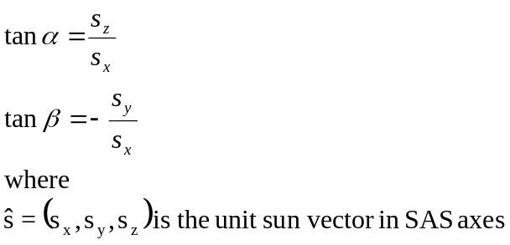
A simple albedo model is used which tests for the earth's disk intersecting the QSS field of view:
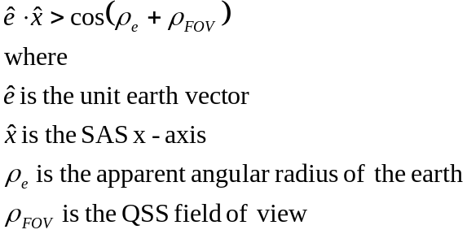
If the earth's disk intersects the field of view an offset is added to the sun aspect angles.
The formulae for computing the areas of QSS quadrants 1 to 4 are given in Table s 1.1.5-1 to 4 respectively, where:
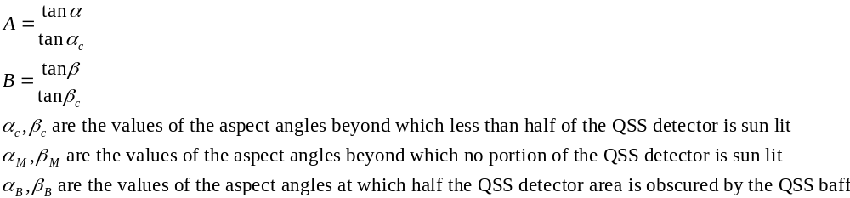
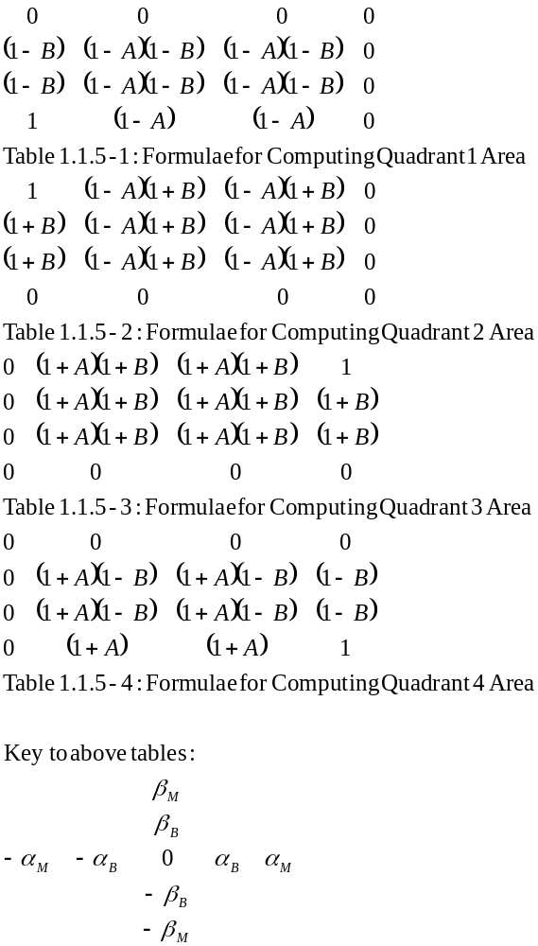

The QSS output currents are then given by:
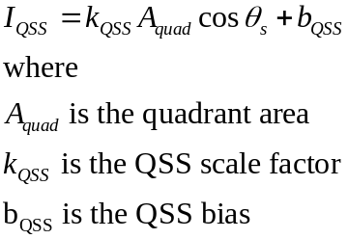

MGM_Model
The magnetic field in spacecraft body axes is given by:
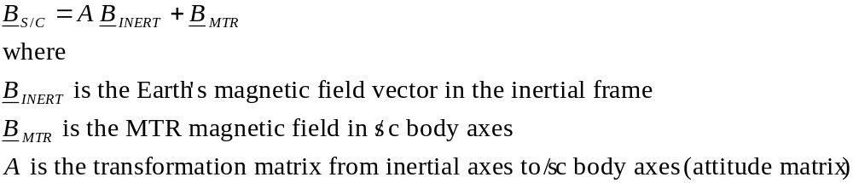
The magnetic field in magnetometer axes is then given by:
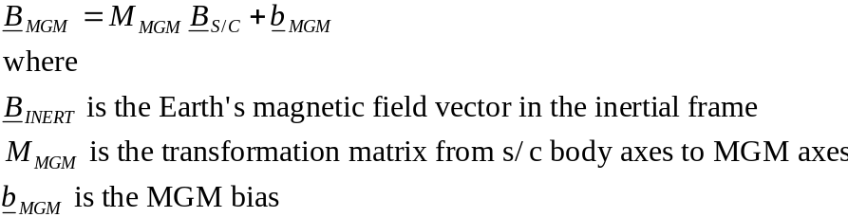

MTR_Model
The coil currents are calculated according to:
• The power status to each coil
• The failure status of each coil
The magnetic moment is calculated according to:
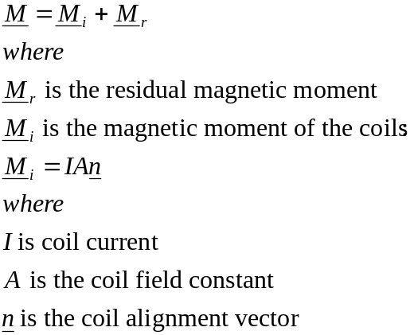
The Earth's magnetic field vector as calculated by the environment model is transformed from the inertial frame to the spacecraft frame by multiplying by the attitude matrix.
The MTR torque is then given by:
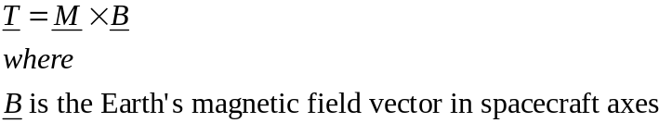

RWL_Model
The wheel speed is given by:
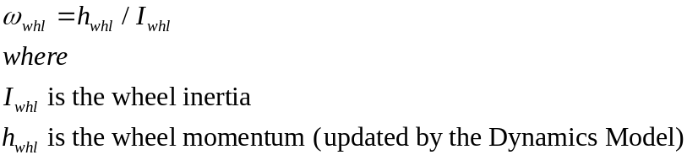
The motor torque is calculated according to:
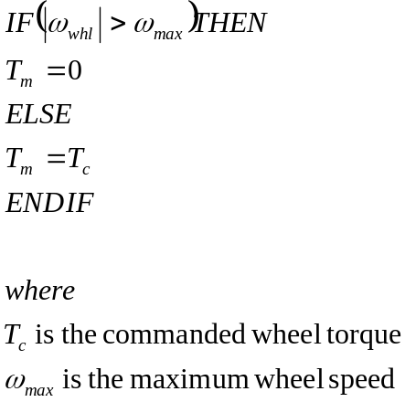
The torque and power limitation are given by:
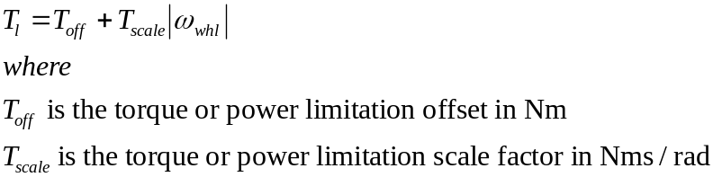

The motor torque is then the minimum value of either the calculated motor torque or the torque or power limitation values.
The motor current is given by:
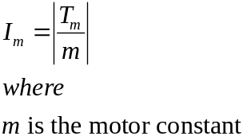

When accelerating the power consumption is given by:
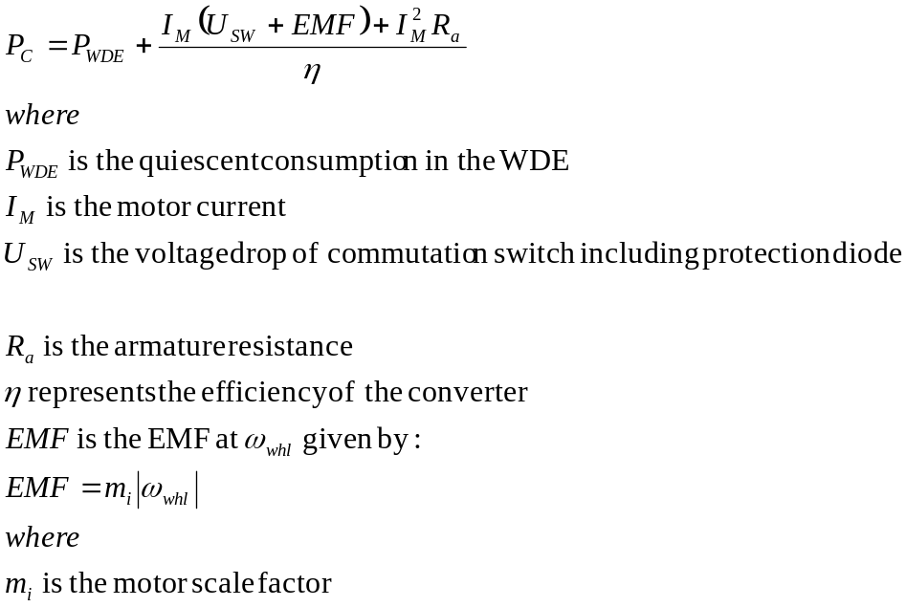
During braking the power drawn from the 28 V bus by the wheel is zero as long as the EMF is high enough to drive the commanded current through the braking regulator:
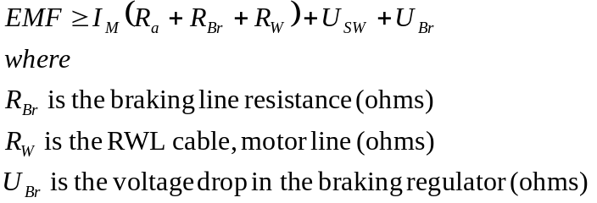
Otherwise the power drawn increases linearly with decreasing wheel speed and the power consumption of the reaction wheel at stand-still given by:
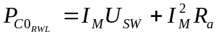
The total power consumtion is obtained by adding on the quiescent consumption in the WDE.

The power dissipation of the reaction wheel is given by:
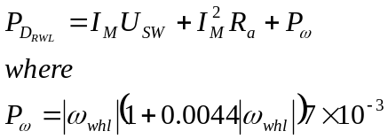
During acceleration the dissipation in the WDE is given by:
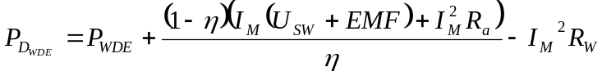
During braking, when the EMF is high enough to drive the commanded current through the braking regulator, the dissipation is given by:
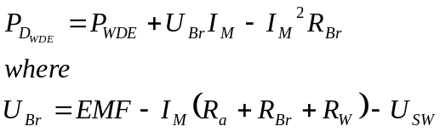
The dissipation is at a minimum when the voltage drop of the braking regulator is just in saturation. Thereafter the power dissipation increases linearly with decreasing wheel speed and the power dissipation of the WDE at stand-still given by:
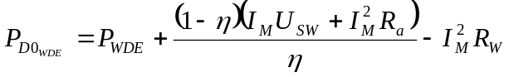

The friction torque is calculated according to:
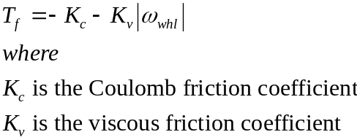
For wheel speeds close to zero the sign of the friction torque is multiplied by the sign of the motor torque otherwise it is multipled by the sign of the wheel speed.
The output wheel torque is then given by:
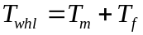
and the wheel acceleration is given by:
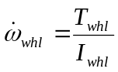
Wheel stiction is modelled as follows:
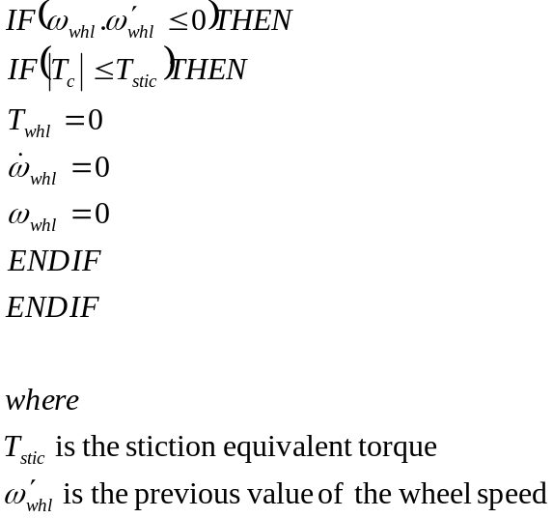
The wheel momentum is recalculated as:
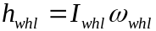
The Tachometer output is given by:
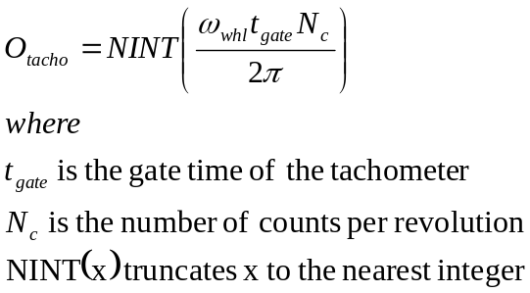

RCS_Model
The pressurant volume is given by:
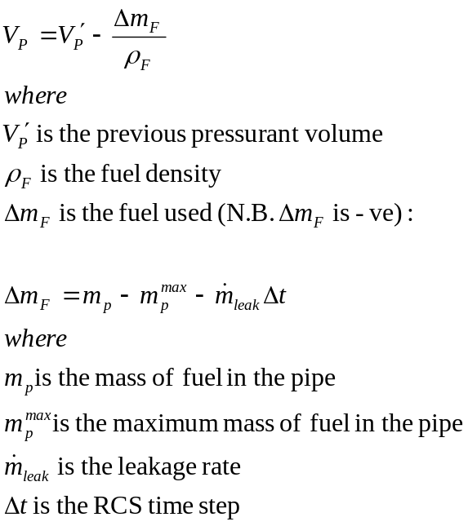
The thrust level, 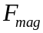 ,is determined by a table lookup of thrust against line pressure (see Figure 1.1.3-1).
The line pressure is dependant on the state of the latch valve. When the latch valve is open the line pressure is equal to the tank pressure which is given by:
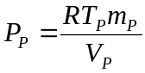
When the latch valve is closed the line pressure is assumed to be dependant on the fuel remaining in the pipe:
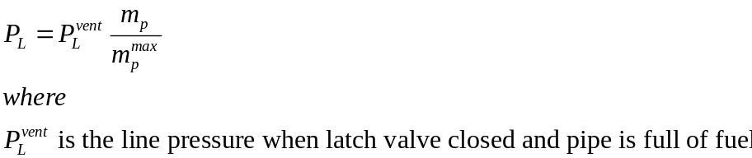
The fuel remaining in the pipe is given by:
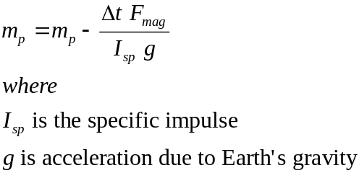
The force produced by each thruster is given by:
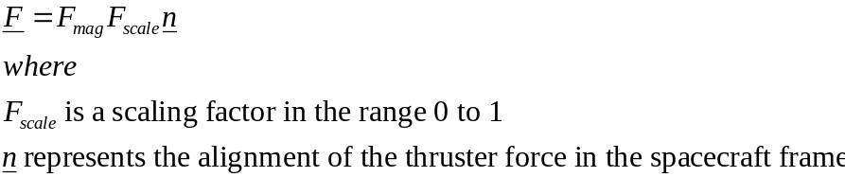
The thruster torque is then:
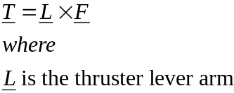
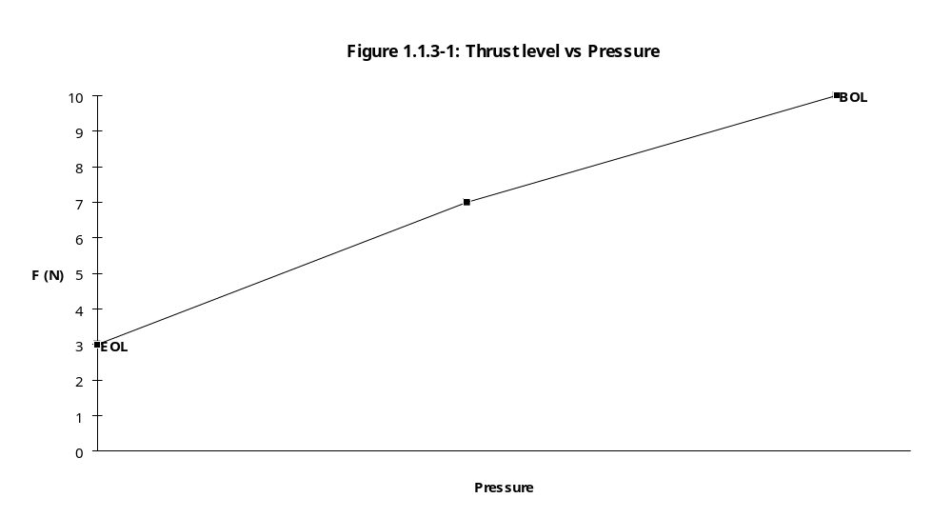

RCS_Model_Init
The initial pressurant volume is given by:
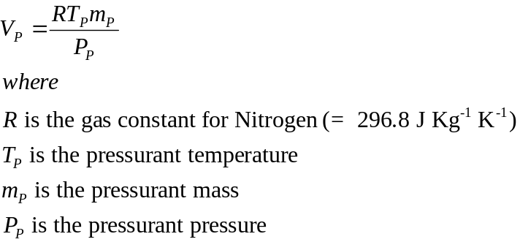
The thruster lever arms are calculated according to:
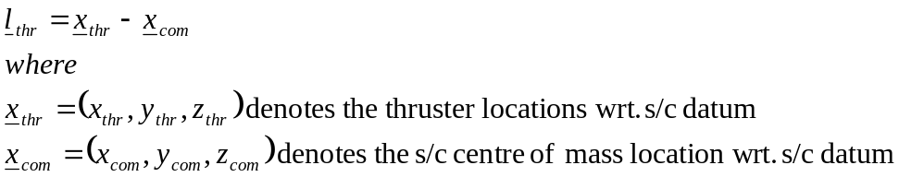

RCS_CatBed_Temp
The Trend calculation for the Catalyst Bed temperatures is of the form:
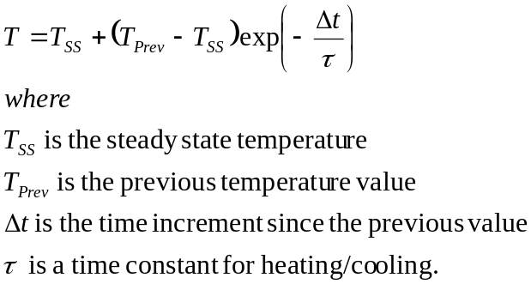

EM_PosVel
This function gets the inertial position and velocity from the six orbital elements : semi-major axis (a), eccentricity (e), inclination (i), ascending node (Ω), argument of perigee (ω) and true anomaly (υ).
The equations used are as follows (see "Orbital Motion" by A.E.Roy):
Given orbital elements a, e, i, Ω, ω, and ν, the position vector R =(x, y, z), and the velocity vector 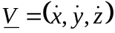, are defined by:
(1) 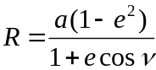
To find the components in the inertial coordinate frame of a vector along the radial direction define a coordinate frame Ψ, with the x-axis pointing along the radial vector, the z-axis pointing to the pole of the orbit and the y-axis making a right handed orthogonal system. It can be seen that the position vector in the inertial frame is given by:
(2) 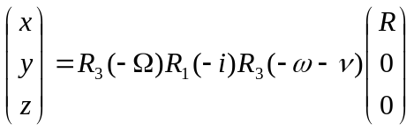
where Ri(θ) is a rotation about the i-axis by an angle θ. The components x, y and z can then be found from:
(3) 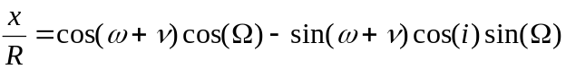
(4) 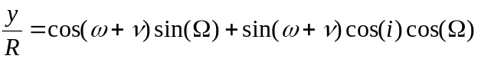
(5) 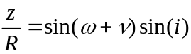
A unit vector along the y-axis of the Ψ coordinate frame has inertial coordinates (a, b, c) given by:
(6) 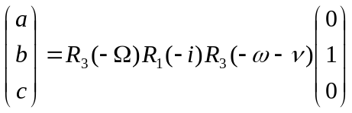
(6a)
(6b)
(6c) 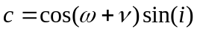
Now it can be shown that the velocity vector has a magnitude ratio of esin(ν) along the x-axis of Ψ to 1+ecos(ν) along the y-axis. Consequently a vector in the direction of the satellite velocity vector has a direction given by:
(7) 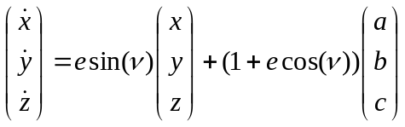
This vector can be normalised to yield a unit vector along the direction of the velocity vector. The magnitude of the velocity is then given by:
(8) 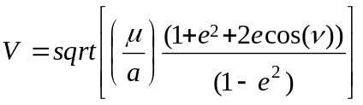

EM_Elements
The equations used are as follows (see "Orbital Motion" by A.E.Roy):
Given a position vector R =(x, y, z), and a velocity vector V, the angular momentum vector h, is defined by:
(1) 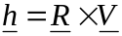
the semi-major axis a, is defined by:
(2) 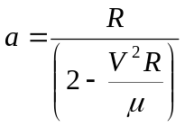
the inclination i, is given by:
(3) 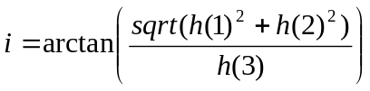
and the eccentricity e, is defined by:
(4) 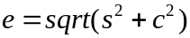
where:
(5) 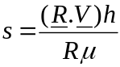
and:
(6) 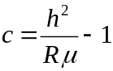
If i≠0, the ascending node Ω, is given by:
(7) 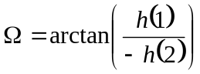
If e≠0, the true anomaly ν, is given by:
(8) 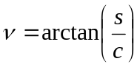
and ω+ν, is given by:
(9) 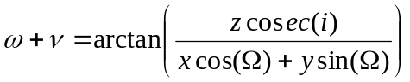
thus determining ω (since υ is known).

EM_EA_From_TA
The equation relating the eccentric anomaly E, to the true anomaly ν, is:
(1) 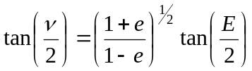
where e is the eccentricity.

EM_MA_From_EA
Kepler's equation, relating the Mean Anomaly, M, to the eccentric Anomaly, E, is as follows:
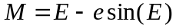
where e is the eccentricity.

EM_Perturb
Determines the rates of change of the orbital elements due to the following perturbations:
1. atmospheric drag;
2. solar radiation pressure;
3. earth oblateness;
The accelerations (fx, fy, fz) due to air drag, SRP and Earth oblateness are derived in the inertial coordinate frame (X, Y, Z). These need to be transformed to a coordinate frame within the satellite (W, T', N) such that W is perpendicular to the orbital plane, T' points along the satellite velocity vector and N completes a right handed system. (For a near circular orbit, N would be approximately in the negative radial direction.)
Writing the accelerations in this frame as (fW, fT', fN) it is seen that:
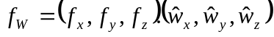
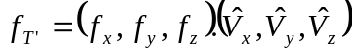
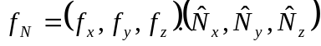
where 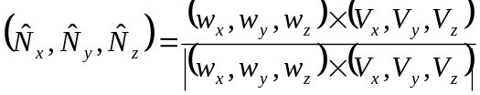
and where 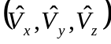 is a unit vector in the direction of the s/c velocity, 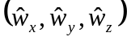 a unit vector in the direction of the s/c angular momentum and 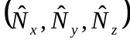 a unit vector perpendicular to these two.
Then, from "Orbital Motion" and after some algebraic manipulations, the rates of change of the orbital elements are given by the following form of Lagrange's Planetary Equations:
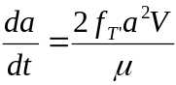
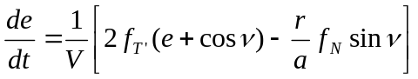
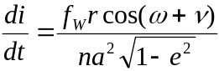
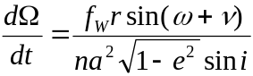
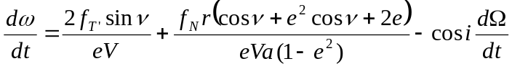
It is seen that some of the above equations become ill defined for zero eccentricity and inclination and since SAX has both nominally low eccentricity and inclination, they can become numerically unstable. Consequently, it is necessary to define the following orbital elements for determining the perturbations:
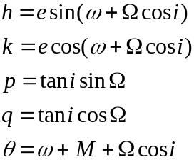
The rates of change to these elements are then given by:

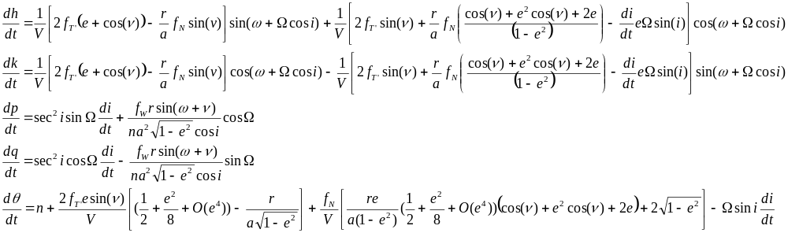EM_Pearth
The gravitational potential, U, can be expressed in terms of zonal spherical harmonics as:
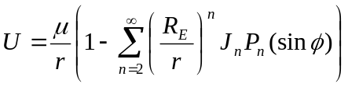
where μ is the Earth's gravitational constant, RE the earth radius at the equator, r the satellite distance, Jn the zonal harmonic coefficient of degree n, Pn the Legendre Polynomial of degree n and φ the s/c latitude.
The oblateness perturbation, U2, is given by the second degree term:
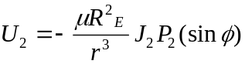
The accelerating force (fx, fy, fz) is given by the gradient of this potential and it can be shown that the components are given by:
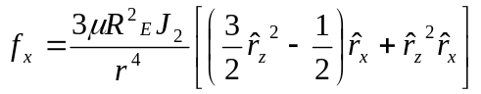
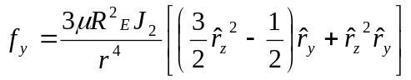
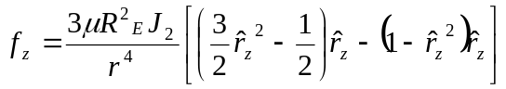
where (rx, ry, rz) is a unit vector in the direction of the s/c radial vector.

EM_Pairdrag
The accelerating force, FDRAG, due to atmospheric density is given by:
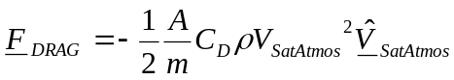
where A is the s/c area normal to the direction of the s/c velocity vector relative to the atmosphere VSatAtmos, CD is the drag coefficient and ρ is the atmospheric density.

EM_Psolarad
The accelerating force, FSRP, due to Solar Radiation Pressure can be written as:
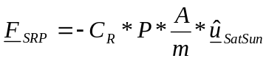
where A is the s/c area normal to the direction of the s/c to sun unit vector 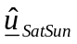, CR is the SRP coefficient and P is the momentum flux at the s/c position (defined as solar flux/speed of light).

EM_Orbit_Update
Updates the orbital elements from the 'current epoch time' to the 'current epoch time plus the timestep' (T+δT) by integrating the rates of change.
The orbit is updated by a simple 'linear' integration over the timestep, δT:
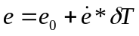
where e is any orbital element, e0 it's initial value and it's rate of change.

EM_EA_From_MA
Kepler's equation, relating the Mean Anomaly, M, to the Eccentric Anomaly, E, is as follows:
In order to solve this for E, it is necessary to proceed iteratively using the Newton-Raphson procedure.

EM_TA_From_EA
The equation relating the Eccentric Anomaly, E, to the True Anomaly ν, is:
(1)
where e is the eccentricity.

EM_Model_Magnetic_Field
The Earth's magnetic field vector, B, can be expressed as the gradient of a scalar potential function V where V is given by:
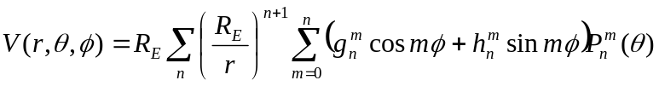
and r is the s/c geocentric distance, θ the geocentric coelevation, φ the geocentric longitude, RE the earth's equatorial radius at the eqautor and gnm, hnm the Gaussian harmonic coefficients.

EM_Planets_Wrt_Earth
Given the planetary heliocentric orbital elements E0, at some epoch T0, and their rates of change dE0/dt, it is possible to determine their values at another epoch T by:
E = E0 + dE0/dt*(T-T0)
From these it is possible to determine the planetary positions in an ecliptic coordinate frame (i.e. a frame with the x-axis pointing towards Aries, the z-axis pointing to the ecliptic pole and the y-axis making a right handed system) using equations (1), (3), (4) and (5) from section 4.1.8.3.3.
These are then rotated into the plane of the earth's equator to produce sun to planet position vectors in the true equatorial system of data coordinate frame.
The earth to planet position vectors are then obtained from the sun to planet position vectors by adding to each, the earth to sun position vector.

EM_Positions_Wrt_Sc
Given a position vector Xepdefining the position of a planet from the earth and a vector Xes, defining the position of the s/c from the earth, the position of the planet from the s/c Xsp is defined by:
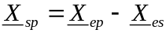
Once new positions have been determined, the apparent radii of the earth, sun and moon as seen from the s/c are updated, as is the amount of solar radiation reflected from the earth

EM_Update_Radii
Given a point P at a distance d, from the centre of a sphere S, of radius r, the apparent radius of the sphere in radians is given by:
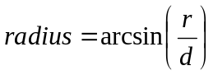

EM_Albedo
Let the solar flux at the earth be FE, the earth albedo factor be α and the earth phase as seen form the s/c be ΦE. Then the albedo radiation, Fsc,at the s/c is given by:
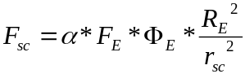

EM_Solar_Disturbances
A simple SRP force model FSRP is given by:
where CR is the SRP coefficient, P is the momentum flux at the s/c position (defined as solar flux/speed of light), A is the surface area with unit normal and is a unit vector in the direction of the satellite to sun vector.
For a satellite composed of several simple geometric shapes Ai, the environmental disturbance torque due to solar radiation pressure TSRP is given by:
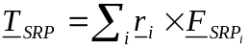
where ri is the vector defining the centre of pressure of area Ai relative to the s/c centre of mass.

EM_Drag_Disturbances
A simple drag force model FDRAG is given by:
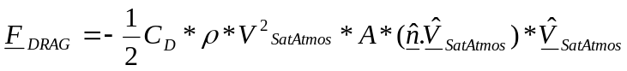
where CD is the drag coefficient, ρ is the atmospheric density at the s/c position, A is the surface area with unit normal and VSatAtmos is the satellite velocity vector relative to the atmosphere.
For a satellite composed of several simple geometric shapes Ai, the environmental disturbance torque due to air drag TDRAG is then given by:
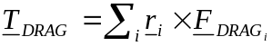
where ri is the vector defining the centre of pressure of area Ai relative to the s/c centre of mass.

EM_Gravity_Disturbances
See Wertz Section 17.2.1.

EM_Aspect_Angle
The solar aspect angle θ, is given by:

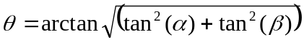
where:
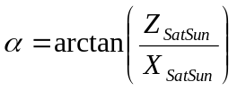
and:
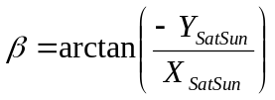

EM_Eclipse_Status
It is assumed that the s/c can be eclipsed by the earth or the moon. The eclipse status is then given by:

EM_Flux
The solar flux Sflux, at the s/c is given by:

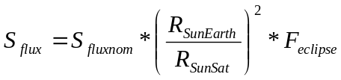
where Sfluxnom is the nominal solar flux in W/m2 at a distance of RSunEarth (=1AU), RSunSat is the distance of the s/c from the sun and Feclipse is the sun eclipse factor.

EM_Earth_Fixed
The geodetic height, h, of a point a distance r from the Earth's centre is given by:
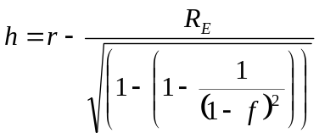
where f is the Earth's flattening (1/298.257).
The Greenwich Sidereal Time, GST, is given by a polynomial of the form:
where G0, G1, G2 and G3 are constants and T is the number of Julian centuries from 2000.0.
The satellite geocentric longitude, λ, is given by:
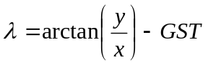
and the satellite geocentric latitude, φ, is given by:
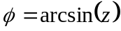
where r = (x, y, z) is the satellite position vector.

EM_Visible
Ground station visibility is checked by determining the angle between the ground station to satellite vector and the station zenith vector to see if it is less than the FOV half cone angle of the ground station. The station zenith vector is the vector along the normal to the Earth ellipsoid at the ground station position (xGS, yGS, zGS) whose direction is given by:
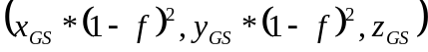
where f is the earth flattening.
If the s/c is visible the ground station aspect angle is computed else it is undefined (TBC).

EM_Orbit_Counter
The orbit counter C, is used to represent the number of orbital passages (i.e orbital revolutions) at the current epoch time T from some initial orbit counter (zero at launch) C0 at time T0. Consequently it is given by:
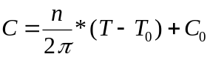
where n is the mean motion in radians/second.

EM_Vel_SatAtmos
The velocity of the atmosphere Vatmos at the s/c position r is given by:
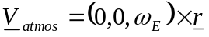
where ωE is the rotation rate of the atmosphere (assumed to be equal to that of the earth).
The velocity of the s/c relative to the atmosphere VSatAtmos is then given by:
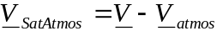
where V is the inertial s/c velocity.

EM_Density
The density ρ is given by the following simple density model:
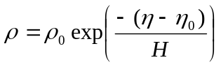
where ρ0 is the density at the reference height of η0, η is the current geodetic height and H is the scale height all in km.

DYN_Calc_Attitude_Matrix
The attitude matrix A is given by:
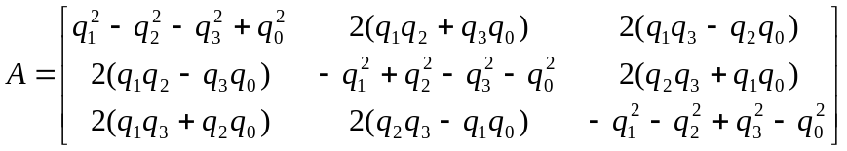
where q is the quaternion given by :
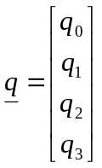

DYN_Calc_Euler_Angles
The (3-1-3) Euler angles are given by:
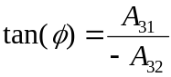
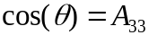
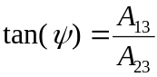
Where A is the attitude matrix descibed in Section 4.1.7.1. Singularities occur when 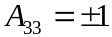. When this occurs we assume:
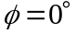
and then for 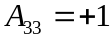
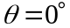
else for 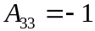
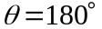
The remaining Euler angle is then given by:
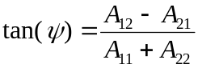

DYN_Calc_Oper_Dist_Torque
The operator has the capability of introducing arbitrary constant, periodic or instantaneous disturbance torques about any or all of the control axes.
The operator supplies a disturbing torque amplitude A in Nm (or impulse in Nms), frequency f in Hz and an on-time duration ton in seconds. The disturbing torque is then given by:
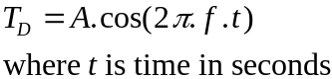
For a constant torque the frequency f is set to zero. For an instantaneous torque the on-time is set to zero and the amplitude A is supplied as a torque impulse in Nms. For a periodic torque the amplitude and frequency f are set as appropriate. The on-time gives the duration for the constant and periodic torques.

DYN_Calc_Quaternions
The quaternions are calculated as follows:
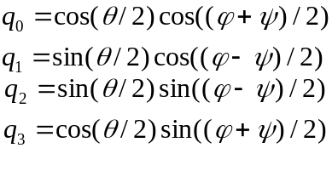

DYN_Flex_Dynamics
The flexible dynamics model employs a generalised system mass matrix formulation. The spacecraft is assumed to consist of a central rigid body with two flexible solar arrays. The following flexible modes are modelled:
mode 1 : 1st bending mode about the z-axis, frequency = 0.54 Hz.
mode 2 : 1st tortional mode about the y-axis, frequency = 1.62 Hz.
mode 3 : 2nd bending mode about the z-axis, frequency = 3.36 Hz.

The following equations of motion are solved :
where
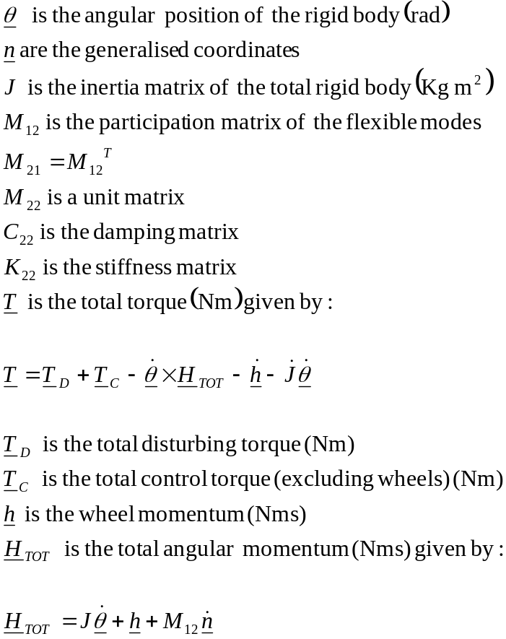

The kinematic equations can be expressed in terms of quaternions as follows :
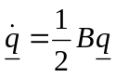
where q is the quaternion given by :
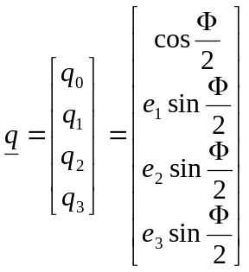
Φ is a rotation about the axis (e1, e2, e3) and B is the matrix given by:
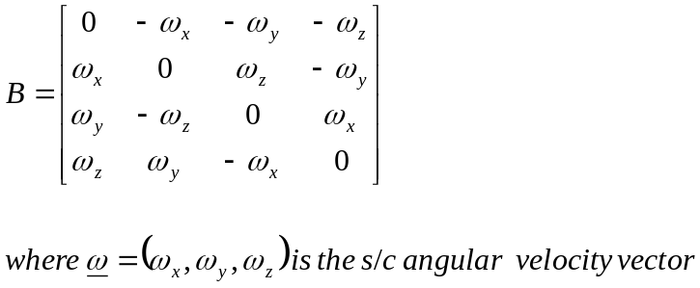

DYN_Rigid_Dynamics
The rigid dynamics model solves Euler's equations of motion:
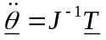
where
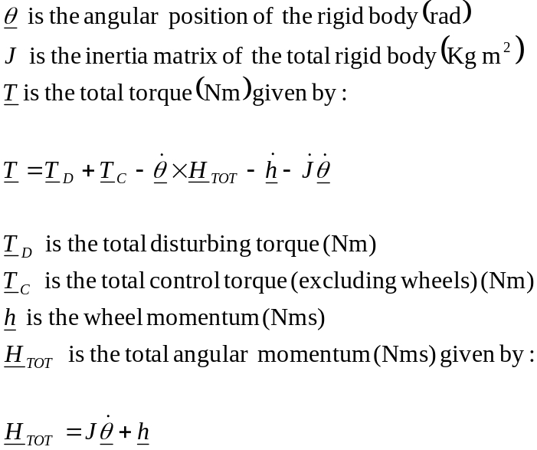
The kinematic equations can be expressed in terms of quaternions as follows :
where q is the quaternion given by :
Φ is a rotation about the axis (e1, e2, e3) and B is the matrix given by:

DYN_Runge_Kutta
The State Vector is composed of:
• Spacecraft body rates in rad/s.
• The spacecraft attitude in terms of quaternions.
• The reaction wheel momenta in Nms.
• The derivatives of the generalised coordinates.
• The generalised coordinates.
For the rigid-body dynamics only the first three bullets are used.
The fourth order Runge-Kutta method is used to update the State Vector, y, as follows:
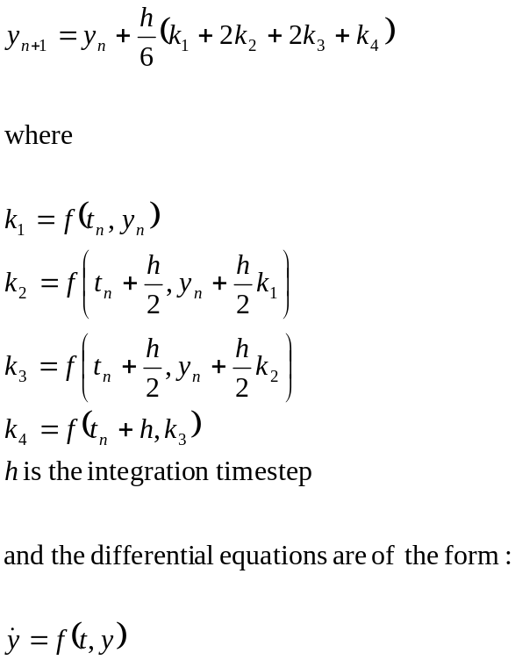

DYN_Update_Mass_Properties
The rate of change of spacecraft inertias as a function of fuel usage are calculated as follows:
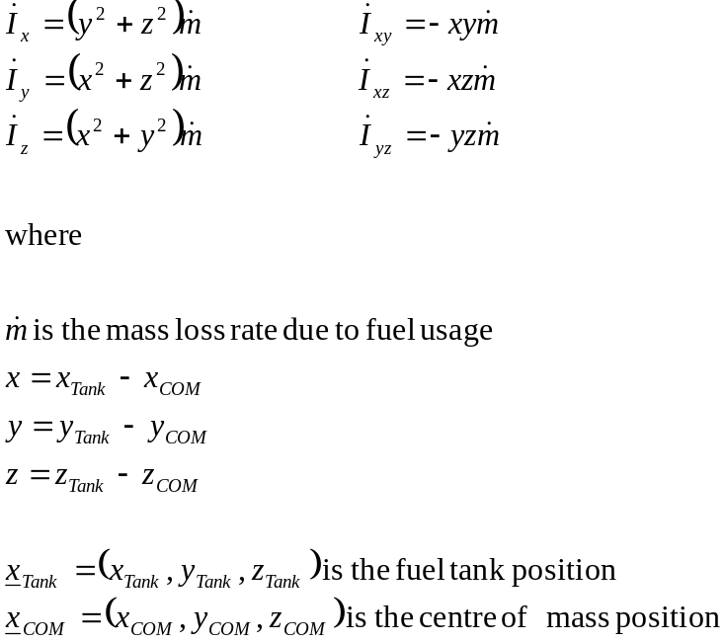
The rate of change of spacecraft inertias as a function of solar array deployment are calculated as follows:
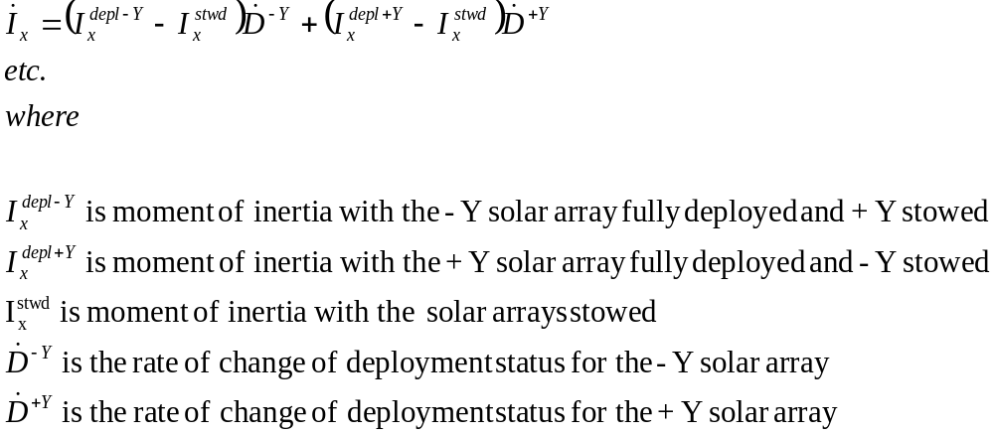Deployment statuses are in the range 0 to 1 where 0 indicates stowed and 1 indicates fully deployed.
Shock torques are modelled as impulse torques applied when the solar arrays start or stop moving.
The dry centre of mass position due to solar array deployments is calculated as follows:
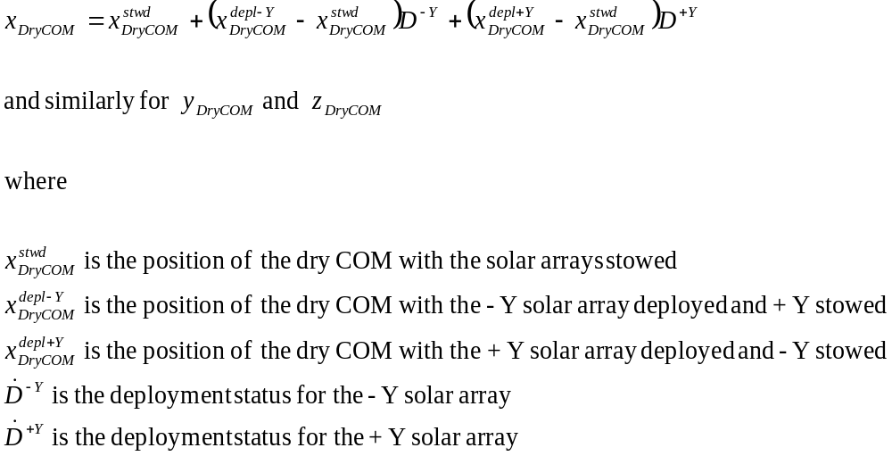The centre of mass taking into account fuel usage can then be determined:
